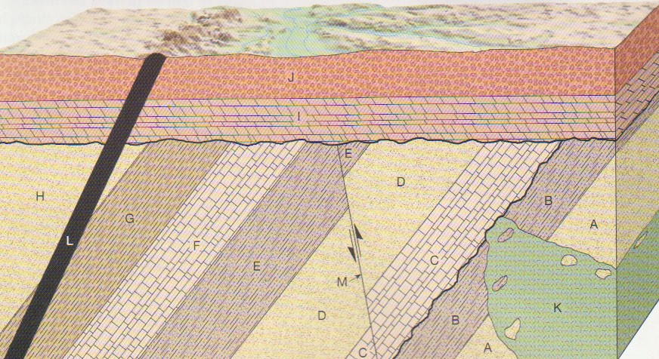

Youngest

_______

_______

_______

_______

_______

_______

_______

_______

_______

_______

_______

_______

_______

_______

_______

_______

_______

Oldest

_______

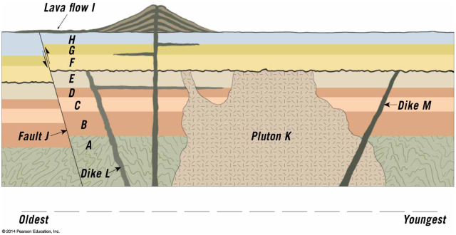

Youngest



_______

_______

_______

_______

_______

_______

_______

_______

_______

_______

_______

_______

_______

_______

Oldest

_______

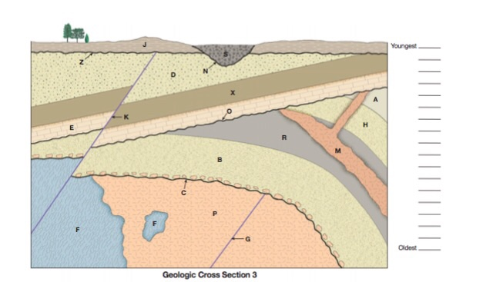

Youngest



(Metamorphic)

(pluton)

In this diagram, the unconformities are assigned their own letters, but please still list them in your list of events as “erosion” – this is what I will require you to do on the test

_______

_______

_______

_______

_______

_______

_______

_______

_______

_______

_______

_______

_______

_______

_______

_______

_______

_______

_______

Oldest